

Game Development:

Dragon Game Report

# Sooriyan Gramani: ST10443023

# Game Start Interface

* Player 1 (gbxPlayer1) - groupbox
* Player Name (lblPlayerName1) - label
* Dragon Name (lblDragonName1) - label
* Player Name Text Box (txtPlayerName1) – textbox
* Dragon Name Text Box (txtDragonName1) - textbox
* Dragon Type (gbxDragonType1) - groupbox
* Fire Dragon (radFireDragon1) - radio button
* Ice Dragon (radIceDragon1) - radio button
* Wind Dragon (radWindDragon1) - radio button
* Earth Dragon (radEarthDragon1) – radio button
* Save (btnPlayerSave1) - button
* Player 2 (gbxPlayer2) – groupbox
* Player Name (lblPlayerName2) - label
* Dragon Name (lblDragonName2) - label
* Player Name Text Box (txtPlayerName2) - textbox
* Dragon Name Text Box (txtDragonName2) - textbox
* Dragon Type (gbxDragonType2) – groupbox
* Fire Dragon (radFireDragon2) – radio button
* Ice Dragon (radIceDragon2) – radio button
* Wind Dragon (radWindDragon2) – radio button
* Earth Dragon (radEarthDragon2) – radio button
* Save (btnPlayerSave2) - button
* Dragon Statistics (lblDragonStats) - label
* Start Game (btnStartGame) - button

# A screenshot of a computer Description automatically generatedPlayer Turn Interface

* X, the X Dragon’s Turn (gbxPlayerTurn) - groupbox
* HP: X (lblPlayerTurnHp) - label
* Attack (btnAttack) - button
* Special Attack (btnSpecialAttack) - button
* Block (btnBlock) - button
* Rest (btnRest) - button
* Opponent: X (gbxOpponent) - groupbox
* X, the X Dragon (lblOpponentDragon) - groupbox
* HP: X (lblOpponentHp) - label
* Battle Log (gbxBattleLog) - groupbox
* Battle Log Rich Text Box (rtbBattleLog) – rich textbox

# Use of Start Game Interface:

The start game interface allows players to input their personal player and dragon names and choose what type of dragon they would like to fight with. This also implements personal customization to your player and dragon. The player turn interface cannot function without the input of player names, dragon names and dragon types.

# Use of Player Turn Interface:

The player turn interface displays/simulates the battle between the two players and their dragons. The interface allows players to make decisions which will change the way they play the game. The interface displays both players information such as dragon name, player name and dragon health.

# User Input:

Players are required to input their own player name and dragon name, along with selecting what type of dragon they would like to use. Players can choose between a Fire, Ice, Wind and Eart dragon, which all have their own unique statistics for damage, special damage, block damage and health. These options make players plan ahead as to what dragon is best for them. Players are given the option between Attack, Special Attack and Block when playing the game. This allows players to play in various different ways and strategize when playing.

# Outputs:

The start game interface displays labels and options which is used for player input. The player turn interface outputs the player and dragon names of the current player’s turn in the appropriate group boxes. The opposing player’s information is displayed in the opponent group boxes. When the player chooses between attack, special attack and block, the battle log text box is updated, giving both players the outcome of the player’s decision. Both player’s dragons’ health’s are displayed, keeping them updated as to who is in the lead in the game. When a player’s dragon has defeated the opposing dragon, the battle log will output a winning text along with the victor’s names and disables all controls preventing the game from continuing.

# Why Output would be generated:

Output is generated and displayed to update the player on changes and events in the game. Keeping both players up to date is important as they require their previous outcomes to decide what their next choice in the game will be. The battle log text box is responsible for displaying all outcomes from the choices of both players. Both dragon’s health’s are also displayed and updated after every turn to ensure players are updated and indicates which player is in the lead in the game.

# Logic & Rules of the Game:

The game is a battle between two players and their chosen dragons. On the start game interface, each player is required to fill in their player’s name, dragon name and choose a dragon type. There are 4 dragon types that is Fire, Ice, Wind and Earth. Each dragon has its own different statistics which will be carried forward into the player turn interface.

|  |  |  |  |  |
| --- | --- | --- | --- | --- |
| **Dragon Types** | **Health**  **Points** | **Attack Damage** | **Special Attack Damage** | **Block Damage** |
| **Fire Dragon** | 20 | 5 | 12 | 4 |
| **Ice Dragon** | 30 | 4 | 9 | 5 |
| **Wind Dragon** | 40 | 3 | 7 | 5 |
| **Earth Dragon** | 50 | 2 | 5 | 6 |

Players are required to input all information to start the game. Player Name and Dragon Name variables are assigned to the text inputted in the Player Name text box and Dragon Name text box when the Save button is pressed. When the player checks the radio button when selecting a dragon type. The statistics, i.e. HP, damage, attack damage, special attack damage and block damage, for that dragon type is assigned to the player’s dragon.

When both players have pressed the save button and have pressed the start game button, the start game interface form is closed, and a new player turn form is opened. When opening the new window, a dice roll is initiated to determine which player starts the battle. The player that gets a higher value starts the game first. When the player turn interface is opened, the player is given a choice between 3 options i.e. Attack, Special Attack and Block. Both players’ information is displayed in the appropriate group boxes.

## Player Options:

If the player selects Attack, the attack damage variable is deducted from the opposing dragon’s Health Points. If the opposing player has chosen Block before the attack was initiated/before the current player’s turn, the attack damage is reduced [Damage = (attack damage -- block damage)] before deducting from the opposing dragon’s health.

If the player selects Special Attack, the special attack damage variable is deducted from the opposing dragon’s HP. If the opposing player has chosen Block before the special attack was initiated, the attack damage is reduced [Damage = (special attack damage -- block damage)] before deducting from the opposing dragon’s health. After the player has chosen special attack, for the next turn that the player who initiated the attack has, the GUI for that player will change subtly, only giving the player the option to Rest, instead of 3 options (Attack, Special Attack, Block). This indicates that the player’s dragon is unable to perform other actions after using a special attack. Once the player has selected Rest, it resets all necessary BlockFlags.

If the player chooses Block, the BlockFlag Boolean is set to true for that player. Whenever the opposing player chooses to attack, that player’s attack damage variable is reduced before being deducted from the dragon’s health. Once the opposing player’s turn is over/ it is the current player’s turn again, the BlockFlag Boolean is set to false as it can only be in effect for 1 turn and cannot be stacked. If both players have selected Block/both players have their BlockFlag set to true, the player that has chosen to Block after, disables the BlockFlag of the player who initiated a block first while still having their own BlockFlag active.

After every event and action, the battle log (rich text box) is updated with a string of text which informs both players of what has occurred in the game and whose turn it currently is. When a player attacks, a string is added to the rich text box, indicating the name of the dragon/player who attacked, the player/dragon that receives the damage, and how much damage is dealt/how much health remains of the player’s dragon. Special attacks output additional text indicating that the dragon who used the special attack “is too tired to fight, and rests for a while”. When a player has blocked, the battle log will differ, showing the amount of damage dealt which excludes the damage deducted by block damage (damage dealt = damage – block damage). Once one dragon’s health reaches 0 or lower, the battle log will output text indicating the victor.

After every round (player 1 action & player 2 action), a dice roll is initiated to determine which player will start in the new round. The player that gets a higher number in the dice roll starts the round first. The game will continue making new rounds until one player’s dragon HP reaches 0 or lower. When a player’s dragon is defeated, the battle log will output text indicating the winner, and all controls will be disabled to prevent the game from continuing.

# Image References:

Dragon Game Background (Form1):

<https://images.app.goo.gl/ndZLDEF3sV8Wuajv5>

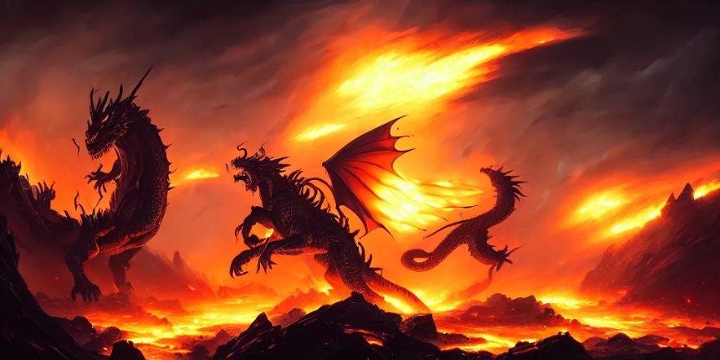

Battle Screen Background (Form2):

<https://images.app.goo.gl/GLFgkG5Bzoybvipn6>



Dragon Logo:

<https://images.app.goo.gl/Y7oGfZdh3ts8Fux66>

